File upload bypass



doepichack

@doepichack

·
Jan 14
simple SVG file upload + bypass for $1500 at
@Hacker0x01
https://doepichack.com/simple-svg-file-upload-bypass-for-1500/… #BugBounty #bugbountytips

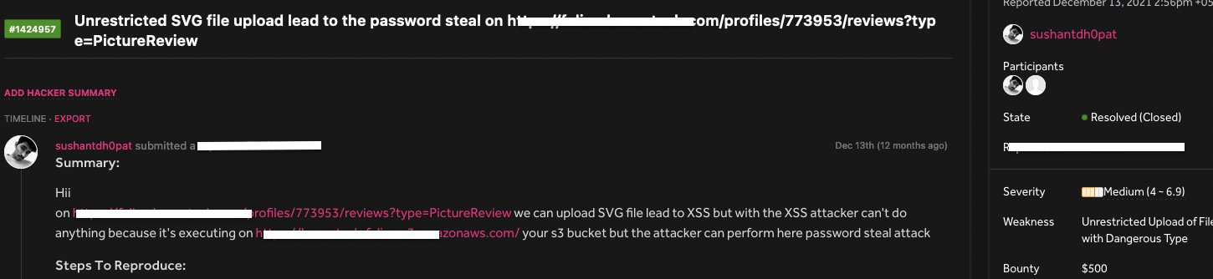

doepichack.com
simple SVG file upload + bypass for $1500 - doepichack
I was testing on HackerOne private program there have file upload functionality I am able to upload their SVG file for the XSS but the file is not uploading on their domain it’s uploading on https:...

1
56
141

10.2K



Frederick Pellerin

@TheRealFREDP3D

·
Aug 20
Simple basic techniques let me root this box: plain text credentials, upload filters bypass for a webshell, php revshell to get user and a SetUID binary file for root. I just pwned Bank in Hack The Box! https://hackthebox.com/achievement/machine/1316243/26… #hackthebox #htb #cybersecurity



hackthebox.com
Owned Bank from Hack The Box!
I have just owned machine Bank from Hack The Box

6

54



Ptrace Security GmbH

@ptracesecurity

·
Feb 21
Upload_Bypass_Carnage - File Upload Restrictions Bypass, By Using Different Bug Bounty Techniques! https://kitploit.com/2023/02/uploadbypasscarnage-file-upload.html… #Pentesting #BugBounty #CyberSecurity #Infosec

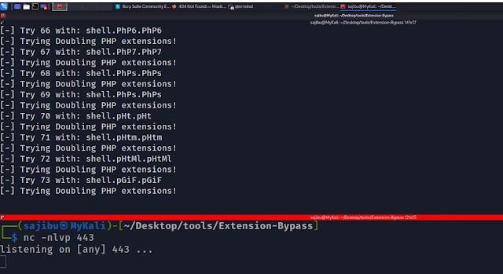

1
23
38

6,961



Harsh Bothra

@harshbothra_

·
Mar 3, 2022
#SecurityExplained Day-62: Vulnerable Code-46 The code is vulnerable to File Upload Bypass attacks. Due to a lack of whitelist utilization, it is possible to bypass the extension check and upload a malicious files.
Quote
Harsh Bothra
@harshbothra_
·
Mar 3, 2022
#SecurityExplained Day-62: Vulnerable Code-46 Can you spot the vulnerability? The solution will be posted later tonight. Code By: @0xRyuk #appsec #Infosec #bugbounty #codereview #codesnippets #hacking #security #developers #securecode #flask #python

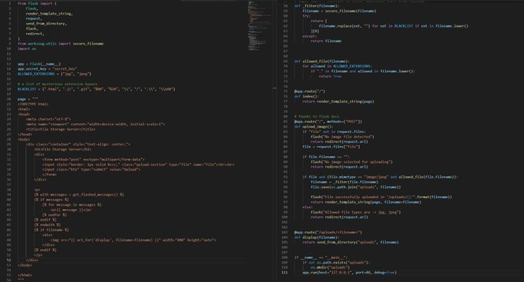

1
13



Cyber Detective

@cyb_detective

·
Aug 12
Vulnerabilities Checklists 2FA bypassing Admin panel Cookie attack Reset Password Attack Account takeover 403 bypass Sql Injection File Upload and more. https://github.com/Az0x7/vulnerability-Checklist… Creator
@Mahmoud30278295

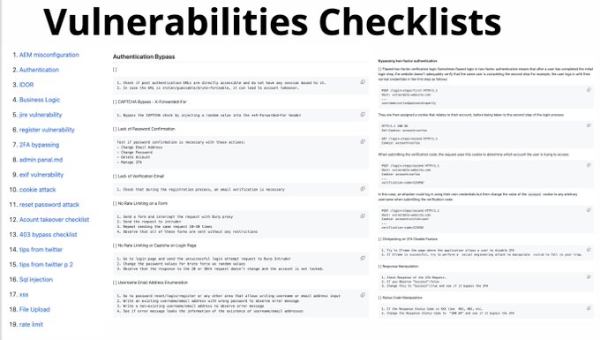

4
90
212

9,609



Dr Marcio B Fasano 

@ComendadorMBF

·
Aug 15, 2022
File Upload Bypass to RCE == $$$$ By
@Sagar__Sajeev
http://sagarsajeev.medium.com/file-upload-by… #hackerone #BugBounty #bugbountytips #hackeronereport #writeups #Bugbountywriteupspublished #bugbountytips #Ethicalhacking #cybersecuritytips #bugbountytip #infosec



Pentesting News

@PentestingN

·
Oct 20, 2022
23000$ for Authentication Bypass & File Upload & Arbitrary File Overwrite https://medium.com/@h4x0r_dz/23000-for-authentication-bypass-file-upload-arbitrary-file-overwrite-2578b730a5f8… Medium 23000$ for Authentication Bypass & File Upload & Arbitrary File Overwrite How I found Authentication Bypass >> File upload vulnerability >> Arbitr… https://t.me/pentestingnews/29310…

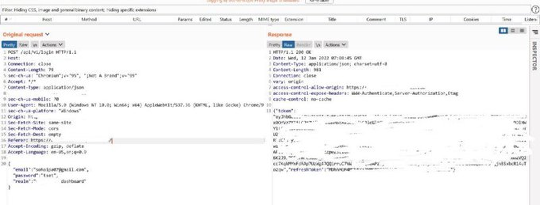



Shah Sheikh

@shah_sheikh

·
Apr 4, 2022
Roxy File Manager 1.4.5 PHP File Upload Restriction Bypass: Roxy File Manager version 1.4.5 proof of concept exploit for a PHP file upload restriction bypass vulnerability. https://packetstormsecurity.com/files/166585/roxy-rce.py.txt?utm_source=dlvr.it&utm_medium=twitter…



CS Threat Intel

@cipherstorm

·
Apr 4, 2022
Roxy File Manager 1.4.5 PHP File Upload Restriction Bypass: Roxy File Manager version 1.4.5 proof of concept exploit for a PHP file upload restriction bypass vulnerability. https://packetstormsecurity.com/files/166585/roxy-rce.py.txt?utm_source=dlvr.it&utm_medium=twitter…



MOJ

@moj_alabi

·
Apr 7, 2022
#100DaysOfHacking #100DaysOfCode Day 15 of 100: I pawned the VM 'ComingSoon' on
@hackmyvm
. Used Cookie forgery and a file upload blacklist bypass to gain root access to a Reverse Shell. https://hackmyvm.eu/achievement/?achievement=5804…
1
4
5



 KitPloit - Hacker Tools

@KitPloit

·
Aug 5
Upload_Bypass - File Upload Restrictions Bypass, By Using Different Bug Bounty Techniques Covered In Hacktricks

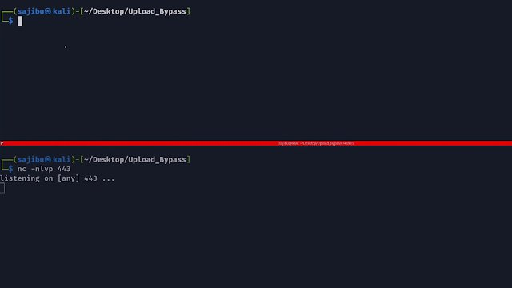

kitploit.com
Upload_Bypass - File Upload Restrictions Bypass, By Using Different Bug Bounty Techniques Covered...
Upload_Bypass is a powerful tool designed to assist Pentesters and Bug Hunters in testing file upload mechanisms. It leverages various bu...

28
41

6,032



DotNetRussell

@DotNetRussell

·
Nov 21, 2022
·
This is a great video from STÖK on a file upload bypass and local file inclusion #RedTeam #RedTeaming #CyberSecurity #bugbountytips #bugbounty
@stokfredrik

youtube.com
A $7.500 BUG BOUNTY Bug explained, step by step. (BLIND XXE OOB over...
Have you ever wondered what a $7.500 Bug Bounty bug looks like?In this "re-upload" of the original video created in 2019, il walk you through a theoretical "...
4



pentestgod

@pentestgod

·
Aug 19
Bypass most file uploads filters: * htaccess <- upload htaccess * file.svg <- uploading svg = XSS * file.SVg <- must try case mismatch * file.png.svg * file.php%00.png * file.png' or '1'='1 *_/./file.png * file. svg <- invalid ext #bugbounty #bugbountytips #cybersecurity
1

93



kmkz

@kmkz_security

·
Sep 5, 2019
3 vulns #exploit chain used in #PenTest 45 days ago -> #ACL bypass+SQLi+RCE via file upload :S CVE-2019-14252/14253/14254 - No magic 0days here: https://github.com/kmkz/exploit/blob/master/PUBLISURE-EXPLOIT-CHAIN-ADVISORY.txt… #Pentesting #CVE #disclosure cc
@Publisure
@jeefers
Quote
kmkz
@kmkz_security
·
Sep 4, 2019
after 45 days, tomorrow will be publication day regarding the exploit chain used against a weak PHP web app. pwnd during a #PenTest (from 0 to local admin then D.A) - #nothingcrazy

Burp Bounty

@BurpBounty

·
Jan 20, 2021
Have you a Unrestricted file upload but the RCE is not possible due a cloudflare protection? This cloudflare bypass works for me: $python -c "print '\n'*132000" >file1.php $cat webshell.php >> file.php Credits: https://swascan.com/cloudflare/
@BurpBounty
#bugbountytips

swascan.com
How to bypass the Cloudflare WAF using a padding technique
Cloudflare - During a Penetration Testing engagement, the Swascan Cyber Security Research Team (CSRT) discovered that it may be possible to bypass the WAF

3
106
254



Tib3rius

@0xTib3rius

·
Dec 3, 2020
Just completed the Day 2 task (The Elf Strikes Back!) of
@RealTryHackMe
's Advent of Cyber! https://tryhackme.com/room/adventofcyber2… Fun little file upload bypass to get a PHP shell!
2
3
105



ZeroDayCVE

@ZeroDayCVE

·
Feb 18
Upload_Bypass_Carnage - File Upload Restrictions Bypass, By Using Different Bug Bounty Techniques!: File Upload Restrictions Bypass, By Using Different Bug Bounty Techniques! POC video: File upload restrictions bypass by using different bug…

kitploit.com
Upload_Bypass_Carnage - File Upload Restrictions Bypass, By Using Different Bug Bounty Techniques!
File Upload Restrictions Bypass, By Using Different Bug Bounty Techniques! POC video: File upload restrictions bypass by using differ...

1

87



Security News Bot

@SecurityNewsbot

·
Jun 14, 2021
[webapps] Subrion CMS 4.2.1 - File Upload Bypass to RCE (Authenticated) https://exploit-db.com/exploits/49876 #ExploitDB



Clint Gibler

@clintgibler

·
Jul 1, 2021
Replying to
@clintgibler
@paulschwarzen
and 12 others
File Upload Master Class
@barracud4_
Media payloads https://github.com/barrracud4/image-upload-exploits… @carlospolopm,
@HolyBugx
Checklist, bypass filters https://book.hacktricks.xyz/pentesting-web/file-upload…
@owasp
Unrestricted File Upload https://owasp.org/www-community/vulnerabilities/Unrestricted_File_Upload… Cheatsheet https://cheatsheetseries.owasp.org/cheatsheets/File_Upload_Cheat_Sheet.html… #bugbountytips #bugbounty



book.hacktricks.xyz
File Upload

1
24
43



Hasu 

@apertureless

·
Sep 16, 2022
So, after 30 mins of poking we got - unprotected endpoints (read / write! ) - Stored XSS - Session Hijacking / Account Takeover through XSS - File Upload bypass => webshell I guess I now have to prepare the report and start #ResponsibleDisclosure
1



/r/netsec

@_r_netsec

·
Jul 7, 2019
Automated
Cisco Data Center Network Manager: auth bypass + file upload = RCE as root https://raw.githubusercontent.com/pedrib/PoC/master/advisories/cisco-dcnm-rce.txt



Teos Consulting

@teosconsulting

·
Apr 4, 2022
Roxy File Manager 1.4.5 PHP File Upload Restriction Bypass: Roxy File Manager version 1.4.5 proof of concept exploit for a PHP file upload restriction bypass vulnerability. http://dlvr.it/SMy3Jm



Kalifornia909

@kalifornia909

·
Aug 1, 2021
New blog post is up for another fantastic TryHackMe room called rootme. It was a fantastic file upload bypass room. Come check out the writeup. https://kalifornia909.info/post/try-hack-me-rootme/… #csdwriteupchallenge #tryhackme #cybersecurity #pentesting #pentester #ethicalhacking #ethicalhacker #cyber

kalifornia909.info
Try Hack Me RootMe
TryHackMe - RootMe

1
3



WordPress News

@Wordpress_Newz

·
May 30, 2019
WP Security Alert: WP Live Chat Support Pro - File Upload Bypass https://wpvulndb.com/vulnerabilities/9320…
1



Sanzu © 

@morodog

·
Aug 30, 2019
Sentrifugo 3.2 – File Upload Restriction Bypass: # Exploit Title: Sentrifugo 3.2 - File Upload Restriction Bypass # Google Dork: N/A # Date: 8/29/2019 # Exploit Author: creosote # Vendor Homepage: http://sentrifugo.com # Version: 3.2 # Tested on:… http://bit.ly/2NBVOah



Nicolas Krassas

@Dinosn

·
Aug 5
Upload_Bypass - File Upload Restrictions Bypass, By Using Different Bug Bounty Techniques Covered In Hacktricks

Rakesh Elamaran

@rakeshoffcl

·
Nov 18, 2021
#100dayslearning Day85 ✓Osintgram tool https://youtu.be/NWyqSbnsvGU by
@NetworkChuck
Never know this ✓Solved Command injection labs in
@PortSwiggerRes
✓Learnt about File Upload - Bypass Content Type and Magic Number #cybersecurity #bugbounty #learning #Hackers #osint #tool
youtube.com
Instagram OSiNT
become a HACKER (ethical) with ITProTV: (30% OFF): https://bit.ly/itprotvnetchuck or use code "networkchuck" (affiliate link)Use a Python hacking tool calle...
4
3



0xh0llow

@0xnot1337

·
Jul 11, 2021
Replying to
@theXSSrat
Hey sir sorry for disturbing your weekend, i dont like to do this actually but have you seen any writeup or article about file upload bypass where the file upload rename your uploaded file until your file extension for eg .gif?
1



blueblue

@piedpiper1616

·
Dec 9, 2019
GitHub - jra89/CVE-2019-19634: This is a filter bypass exploit that results in arbitrary file upload and remote code execution in class.upload.php <= 2.0.4 -

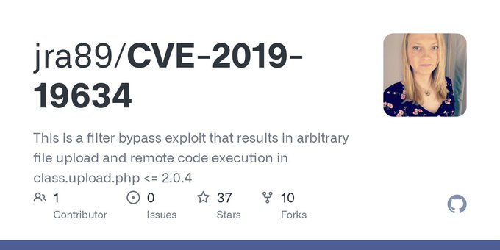

github.com
GitHub - jra89/CVE-2019-19634: This is a filter bypass exploit that results in arbitrary file...
This is a filter bypass exploit that results in arbitrary file upload and remote code execution in class.upload.php <= 2.0.4 - GitHub - jra89/CVE-2019-19634: This is a filter bypass exploit ...

36
114



T̵i̵g̵e̵r̵m̵a̵m̵R̵o̵o̵t̵ ̵

@TigermanRoot

·
Aug 19
Upload_Bypass - File Upload Restrictions Bypass, By Using Different Bug Bounty Techniques Covered In Hacktricks

kitploit.com
Upload_Bypass - File Upload Restrictions Bypass, By Using Different Bug Bounty Techniques Covered...
Upload_Bypass is a powerful tool designed to assist Pentesters and Bug Hunters in testing file upload mechanisms. It leverages various bu...

1

69



Da3m0n8

@da3m0n8

·
Mar 3, 2022
Replying to
@harshbothra_
and
@0xRyuk
File upload bypass by using double encoding like %2520.js.jpg
5

CS Threat Intel

@cipherstorm

·
May 13
[webapps] Job Portal 1.0 - File Upload Restriction Bypass: Job Portal 1.0 - File Upload Restriction Bypass



chivato

@SecGus

·
Mar 26, 2021
Bypass Windows file upload restrictions by adding a trailing '.' to your filename. Windows removes trailing full-stops in filenames automatically, so you can bypass extension blacklists, but still end up with valid files. I.E. shell.php. => shell.php #BugBountyTips
40
181



unknown

@Unknownuser1806

·
Mar 4, 2020
External XML Entity via File Upload (SVG) https://0xatul.github.io/posts/2020/02/external-xml-entity-via-file-upload-svg… Site wide CSRF on a popular program https://fellchase.blogspot.com/2020/02/site-wide-csrf-on-popular-program.html… OK Google: bypass the authentication! https://techblog.mediaservice.net/2020/01/ok-google-bypass-the-authentication… Google Bug Bounty https://santuysec.com/2020/01/21/google-bug-bounty-csrf-in-learndigital-withgoogle-com… #bugbountytips,#bugbounty
66
186



Deepak Dhiman

@Virdoex_hunter

·
Apr 7, 2021
Hey checkout my new video poc Bug : File upload restriction bypass leads to 100 Euros Program : rdp Link : https://youtu.be/jC8TTHgBuq0
@ADITYASHENDE17
@sechunt3r
@1ndianl33t
@remonsec
@sunilyedla2
@SMHTahsin33
@theXSSrat
@impratikdabhi
@dhakal_ananda
@sillydadddy
youtube.com
Bug Bounty PoC: FIle Upload Restriction Bypass
Hello amazing hackers,In this PoC I am able to bypass restriction on file upload using double extension attack.Bounty:100 EurosName : Deepak Dhiman (a.k.a Vi...
3
38
135



Exploit Database

@ExploitDB

·
Mar 25, 2021
[webapps] Dolibarr ERP/CRM 11.0.4 - File Upload Restrictions Bypass (Authenticated RCE) http://dlvr.it/RwKzVz
3
12



Aydin Naserifard

@NaserifardA

·
Dec 18, 2022
NahamCon EU CTF 2022 | Byepass Web Challenge https://youtu.be/ifjMdERchF4
@_JohnHammond
@NahamSec
#Bypepass #upload #NahamCon #CTF #Exploit #denylist #challenge #walkthrough #capturetheflag #file #upload #bypass #event #byepass
youtube.com
NahamCon EU CTF 2022 | Byepass Web Challenge
In this video, I would like to showcase "#Byepass" challenge from the web category of #NahamCon EU CTF event of 2022.#upload #NahamCon #CTF #Exploit #denylis...
1
5

615



Prateek Thakare

@thakare_prateek

·
Apr 18, 2020
#day25 #100daystolearnandimprove - Read about file upload bypass. - This article is good to start: https://medium.com/@satboy.fb/art-of-unrestricted-file-upload-exploitation-92ed28796d0… - Continued with my web application project.

bugdisclose.medium.com
Art of Unrestricted File Upload Exploitation
Hey Whatsup! This is Satyendra an Infosec noob, I hope you are doing well. I’m presenting here my little research on Unrestricted file…

2
10



Steve Campbell

@lpha3ch0

·
Jul 10, 2019
I found an interesting file upload bypass today. If they are only filtering file names, when uploading file.jpg, intercept with Burp/Zap and change the name to file.exe;.jpg.
1
1
11

ZeroDayCVE

@ZeroDayCVE

·
Aug 11
Upload_Bypass - File Upload Restrictions Bypass, By Using Different Bug Bounty Techniques Covered In Hacktricks: Upload_Bypass is a powerful tool designed to assist Pentesters and Bug Hunters in testing file upload mechanisms. It leverages various bug…

kitploit.com
Upload_Bypass - File Upload Restrictions Bypass, By Using Different Bug Bounty Techniques Covered...
Upload_Bypass is a powerful tool designed to assist Pentesters and Bug Hunters in testing file upload mechanisms. It leverages various bu...

1
1

39



payloadartist

@payloadartist

·
Dec 10, 2018
A Handy #security #BugBounty reference on: - Recon - SQLi - XXE (OOB) - #XSS, generic payloads - CSP Bypass - CSRF -> Stored #XSS - CORS - Heartbleed - IDOR - File Upload Based vulns - Deserialisation - CSVi - LFI - RCE - misc stuff...

techvomit.net
Web Application Penetration Testing Notes
XXE Valid use case This is a non-malicious example of how external entities are used: ]> &c; Resource: https://xmlwriter.net/xml_guide/entity_declaration.shtml Testing methodology Once you’ve...

1
103
224



Tushar Verma

@e11i0t_4lders0n

·
Jun 17, 2021
File Upload Restrictions Bypass https://exploit-db.com/docs/english/45074-file-upload-restrictions-bypass.pdf… #bugbounty #bugbountytips #bugbountytip
2
37
91



root@AkashHamal0x01:~/ # 

@AkashHamal0x01

·
Apr 12, 2021
So if you are looking after file upload functionality , you can check the pdf as it has covered most of the tricks to bypass file upload restrictions : https://exploit-db.com/docs/english/45074-file-upload-restrictions-bypass.pdf… so far it is the best source for bypassing file uploads! #bugbountytip #bugbounty #hackerone
1
22
35



I.T Security Labs

@lahilabs

·
Aug 21
Tryhackme Grep Walkthrough . OSINT, File upload bypass and guesswork https://youtu.be/C7y6dr0kQAg via
@YouTube

rami abdelouahab

@ramiabdou91

·
Aug 26
Replying to
@yeswehack
Arbitrary file upload , an attacker can bypass the RE filter by a shell backdoor name "shell.jpg.php"

84



Syed Mushfik Hasan Tahsin

@SMHTahsin33

·
Apr 24, 2021
Here You can find a File Upload Bypass Checklist : https://github.com/HolyBugx/HolyTips/blob/main/Checklist/File%20Upload.pdf…
3
4



Binni Shah

@binitamshah

·
Jul 24, 2018
File Upload Restrictions Bypass : https://exploit-db.com/docs/english/45074-file-upload-restrictions-bypass.pdf… (pdf)
76
144



DEF CON - 9221

@dc9221

·
May 31, 2020
Magic Bytes are the first few bytes of the file's header which are used to identify the file type. They can also be used when trying to bypass file upload filters! #infosec #informationsecurity #hacker #CyberSecurity #cybersecuritytraining #cybersec #appsec #pentest #Hacking

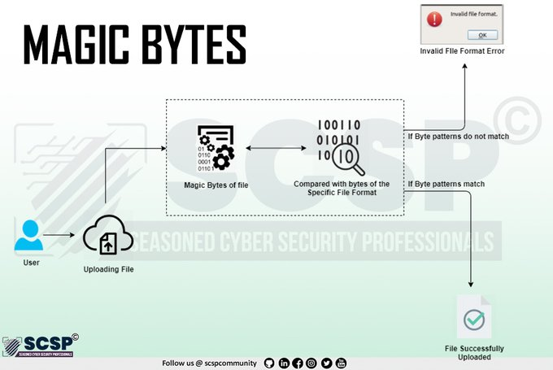

9
16



rkx7

@rkx73

·
Feb 18
#Upload_Bypass_Carnage File Upload Restrictions #Bypass, By Using Different Bug Bounty Techniques

kitploit.com
Upload_Bypass_Carnage - File Upload Restrictions Bypass, By Using Different Bug Bounty Techniques!
File Upload Restrictions Bypass, By Using Different Bug Bounty Techniques! POC video: File upload restrictions bypass by using differ...

2
5

476



National Cyber Security Services

@NationalCyberS1

·
Mar 10
Upload_Bypass_Carnage:-- File Upload Restrictions Bypass, By Using Different Bug Bounty Techniques!

Top

Latest

People

Media

Lists

See new posts

Search timeline



D∆₹KLÖ†Û$

@darklotuskdb

·
May 20, 2020
File Upload Bypass Trick •While uploading shell.php if you are getting error in javascript pop-up. •Then just disable your Javascript from the browser(restart it) and try to upload it again. #HR51KDB #bugbountytips #bugbounty #infosec #Tips
1
11
33



Alex

@alex_

·
Jul 22, 2019
PSA: Last I week I learned that it's trivial to add a JPEG header to a phar file to bypass MIME type validation on file uploads. This way you can get any PHP code to execute through a vulnerable file upload. TL;DR: MIME validation is not good enough & never serve uploaded files

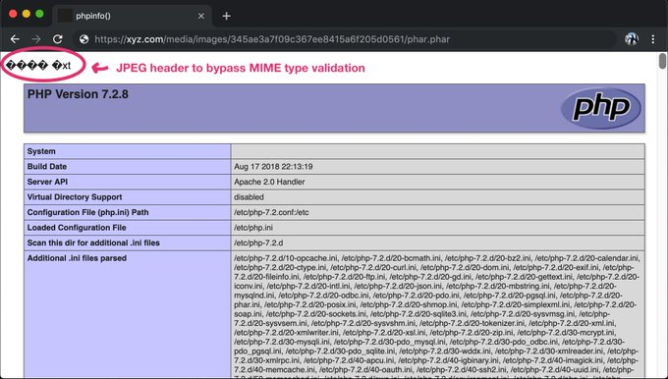

4
64
132



CyCatz

@cycatz2

·
Dec 10, 2021
#bugbountytips #bugbounty File Upload to RCE #pentest #appsec 1. Bypass the filter upload 2. PHP Exploit 3. Remote Code Execution More..https://bit.ly/3ELZD4u

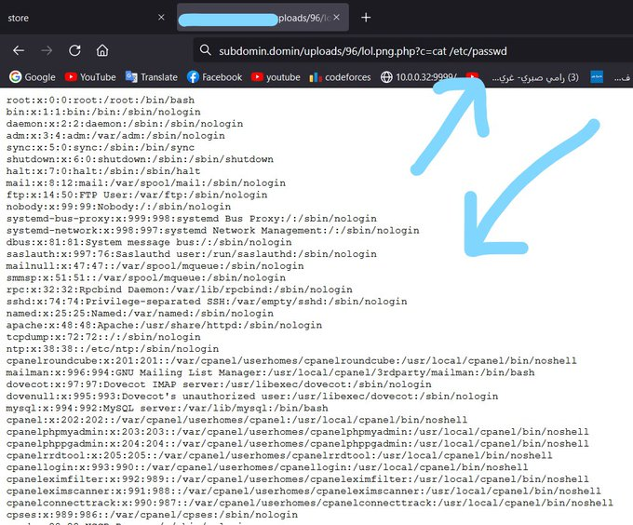

4
64
217



Today Cyber News

@TodayCyberNews

·
Mar 28, 2021
File Upload Bypass - Embed PHP in your photos! - Created by
@NinjaJc01
- https://imagepayload.jc01.ninja - #ctftools #ctf #hacktricks #cybersecuritytips #imagepayload #uploadbypass #hacking #bugbounty #tryhackme #bugbountytips #HackENews

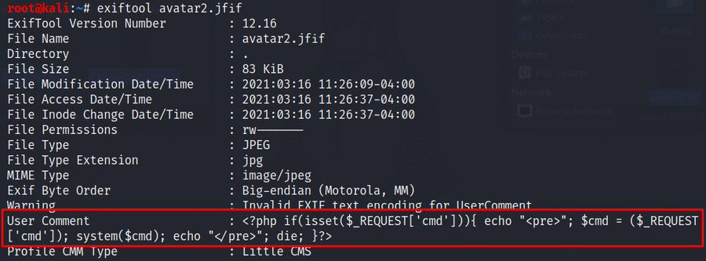

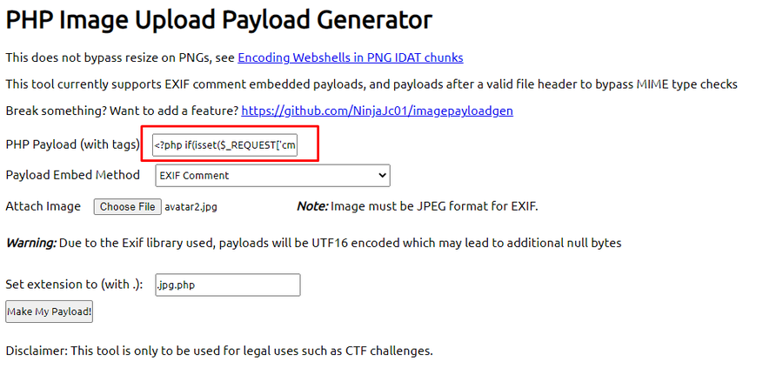

1
24
54



jp / kw0

@JoshuaProvoste

·
Aug 26, 2022
My first RCE in
@Hacker0x01
(11 months ago): 1. Find chat client 2. Open a chat session 3. Upload or bypass the upload file to share content with support team 4. Open the file and boom, easy peasy RCE #bugbounty #bugbountytips #bugbountytip

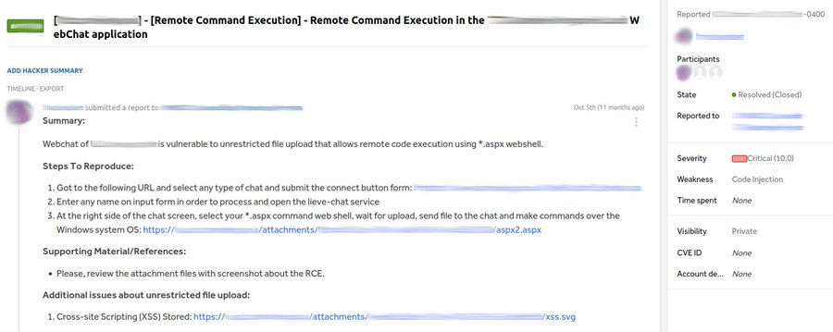

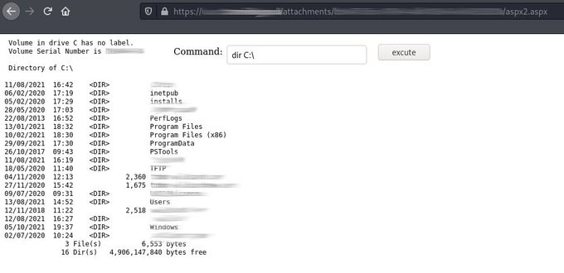

24
90
453



Ankit Kushwah

@loopspell

·
Jan 7, 2021
I just published CVE-2020–29607: Remote Code Execution Via File Upload Restriction Bypass In Pluck CMS ≤ 4.7.13

link.medium.com
CVE-2020–29607: Remote Code Execution Via File Upload Restriction Bypass In Pluck CMS ≤ 4.7.13
File Upload Restriction Bypass in Pluck CMS ≤ 4.7.13 allows an admin privileged user to gain access in the host through the “manage…

14
22



The Bug Bounty Hunter

@tbbhunter

·
Oct 20, 2022
23000$ for Authentication Bypass & File Upload & Arbitrary File Overwrite

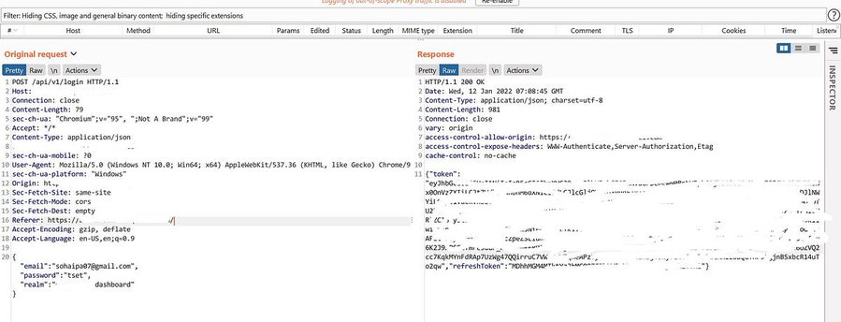

medium.com
23000$ for Authentication Bypass & File Upload & Arbitrary File Overwrite
How I found Authentication Bypass >> File upload vulnerability >> Arbitrary File Overwrite and how I managed I found the path of the file…

1
39
204



Sienna Web Designs

@siennawebdesign

·
May 27, 2020
Drag and Drop Multiple File Upload for #ContactForm7 < 1.3.3.3 - Unauthenticated File Upload Bypass http://ow.ly/E0ub30qJStZ
1
1



Ryan M. Montgomery

@0dayCTF

·
Feb 24
Carnage - File Upload (Extension Bypass) - Using various techniques, this tool will try to bypass file upload restrictions. See video below for more information. - Repo: https://github.com/sAjibuu/upload_bypass… - Video: https://youtube.com/watch?v=quFoDysbDto… - - #cybersecurity #bugbountytips #CTF #infosec

Rahul 

@rahul_i0h1

·
Nov 16, 2021
WAF bypass during exploitation of file upload : WAF bypass discovered during exploitation of a file upload vulnerability. #Google #bugbountytips #hacker #HackTheBox
@HackingTutors
@GodfatherOrwa
@theXSSrat
@Farah_Hawaa
@florinpop1705
@KillSwitchX7
Quote
Pinaki 
@0xInfection
·
Dec 21, 2020
I just uncovered a crazy WAF bypass today. Case: File Upload (.php blocked) /?file=xx.php <- Blocked /?file===xx.php <- Bypassed The file got uploaded successfully. I'm kinda still in a dilemma how it worked, but it does open up new possibilities around WAF bypassing. 
1
13
28



Samuel

@sign3tsh3l1

·
Sep 22, 2020
Work Hour !!!! Unrestricted file upload, bypass file size restrictions with Basic account ....reporting... @hugop1canz0
@impratikdabhi
@RogueSMG
@hunter0x7
@Virdoex_hunter
@remonsec
....Be Inspired 
3
18



Debangshu 

@ThisIsDK999

·
Feb 15, 2021
Let's make this a thread: List atleast one technique you learned from CTFs that you used/can be used IRL Mine: Prepending GIF magic bytes to a malicious php shell led to File-Upload Bypass and command execution. Comment! #bugbountytips #bugbountytip #cybersecurity

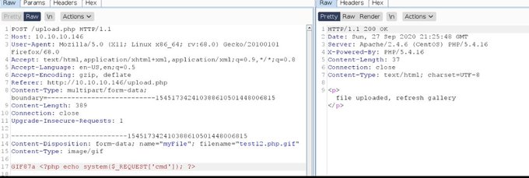

5
48
163



رود | GOAT

@0x_rood

·
May 3
guys i found file upload, already bypass extension with .php 2 and get stored xss, but i want to make it rce or escalate it with critical bug, the problem, it's blocked by WAF (cloudflare) so any tips to get critical severity or get rce? #bugbounty
10
6
56

15.5K



Bug bounty notes

@bugbounty0

·
Nov 1, 2022
23000$ for Authentication Bypass & File Upload & Arbitrary File Overwrite #bugbounty #bugbountytip #infosec #bugbountytips



Sachin Pandey

@sachin_pandey98

·
Apr 18, 2021
Today I have found a Amazing bug on a rdp private progg after spending weeks on same progg Bug name :- File upload restriction bypass causing xss 1.There was a option to upload any certificate in .pdf or .png format 2. So tried to upload pdf file first and seen the mechanism
11
22
113



M. Qasim Munir

@Savitar0x01

·
Oct 8, 2020
Want to bypass file upload restrictions? Add ' , . " after the file extension just like: file.php' , file.php. , file.php" worked on many targets. #BugBounty #bugbountytips

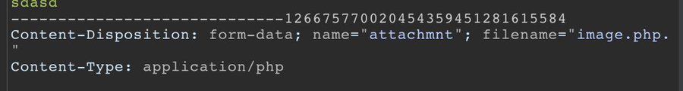

5
105
251

Today Cyber News

@TodayCyberNews

·
May 11, 2021
WAF bypass during exploitation of file upload /?file=rce.php <-- Blocked /?file=rce.php.jpg <-- Blocked /?file=rce.php5 <-- Blocked /?file===rce.php <-- Bypassed 200 OK #bugbonty #bugbountytips #infosec #cybersecurity #bugbountytip #Linux
9
178
443



Arpit Borawake

@_venom26

·
Feb 21, 2020
#100DaysOfLearning #BugBounty #Day36 Hacked for full day submitted 2 bugs Learned about file upload bypass Day ends

Abdalla Abdelrhman

@0x2nac0nda

·
Mar 27
#file_upload-restrictions-bypass Mime type; Content-Type : image/gif Content-Type : image/png Content-Type : image/jpeg #tips
2
10
40

2,747



INTIGRITI

@intigriti

·
Apr 21
Replying to
@intigriti
Upload Scanner (pro-only) Upload Scanner automates file upload vulnerabilities and combines many file upload bypass techniques! It's capable of detecting file upload vulnerabilities such as XSS, XXE and even PHP, JSP or ASP code injection!



portswigger.net
Upload Scanner
Test file uploads with payloads embedded in meta data for various file formats.

1
3
20

2,702



HackGit

@hack_git

·
Aug 10
Upload_Bypass v2 File upload restrictions bypass, by using different bug bounty techniques covered in Hacktricks. https://github.com/sAjibuu/Upload_Bypass… #infosec #pentesting #redteam
0:01 / 0:14
1
184
540

46.8K

INTIGRITI

@intigriti

·
Mar 5, 2020
If you don't read this week's #BugBytes, you'll be missing a juicy file upload vulnerability to bypass AWS signing,
@samwcyo
's sensitive secrets and
@gehaxelt
wordpress madness. Subscribe or miss out!

N0t0d4y

@0xJin

·
Nov 9, 2021
File upload WAF bypass: /?file=shell.php <-- Blocked /?file===shell.php <-- Bypassed #bugbounty #bugbountytips
6
127
357



Felix

@Acardia2020

·
Sep 4, 2021
File upload bypass #bugbounty #bugbountytips

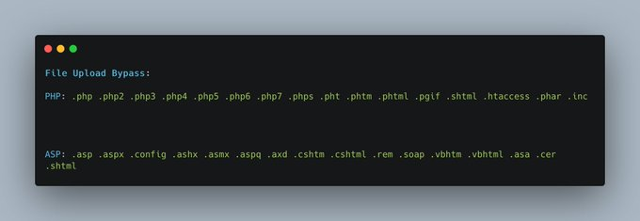

1
15
55

Ryan M. Montgomery

@0dayCTF

·
Mar 16, 2021
File Upload Bypass - Embed PHP in your photos! - Created by
@NinjaJc01
- https://imagepayload.jc01.ninja - #ctftools #ctf #hacktricks #cybersecuritytips #imagepayload #uploadbypass #hacking #bugbounty #tryhackme

7
227
583



Hossein NafisiAsl

@MeAsHacker_HNA

·
Dec 7, 2021
#Pro Bypass file upload restriction by 'MikeChan' 1. Line Termination Trick 2. Content-Disposition Overflow 3. File Name Overflow 4. Duplicated Line 5. Double Extension Another thing comes to your mind? Comment it :) #FileUpload #BugBounty #BugBountyTip #BugBountyTips

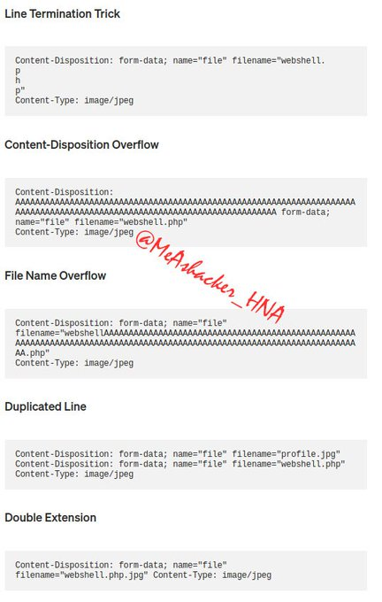



Md Ismail Šojal

@0x0SojalSec

·
May 30, 2022
Unrestricted file upload cloud fare bypass https://sivasimha.medium.com/unrestricted-file-upload-cloud-fare-bypass-12867b65de3a…
9
14

Md Ismail Šojal

@0x0SojalSec

·
Mar 28
file upload restriction bypass: * name filtering: 1) blackboxing: try to use file extentions like: php[3-n],phtml, pht. 2) whitelising: use null-byte:shell.php%00.gif use double extention format : shell.php.jpg or shell.jpg.php #infosec #bugbountytip #cybersecuritytips
3
5

320

INTIGRITI

@intigriti

·
Mar 15, 2021
Testing an upload functionality? Sometimes, an encoded # (%23) will help you to bypass file type restrictions. Thanks for the #BugBountyTip, @seifelsallamy! #BugBountyTips

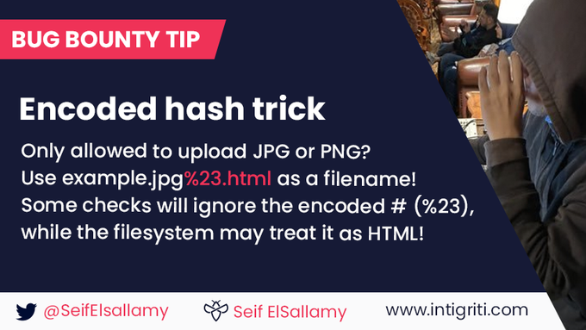

1
94
276



Maniesh.Neupane

@Pwn4arn

·
Nov 14, 2021
File upload WAF bypass: /?file=shell.php <-- Blocked /?file===shell.php <-- Bypassed #bugbounty #bugbountytips



mehdisadir

@silentgh00st

·
Jun 6
THREAD ALERT Here is how i was able to upload a webshell into an old target with already 1000 resolved reports on
@SynackRedTeam
and got my first RCE approved! This was using google dorks, Js inspection and File upload filter bypass.. #bugbountytip #bugbountytips

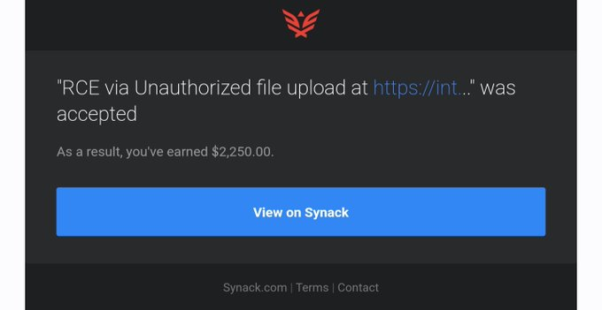

23
104
527

41.2K



N0t0d4y

@0xJin

·
Nov 9, 2021
File upload WAF bypass:



Anonymous H4ck3r

@AnonymousH4ck35

·
Aug 16
Vulnerabilities Checklists 2FA bypassing Admin panel Cookie attack Reset Password Attack Account takeover 403 bypass Sql Injection File Upload and more. https://github.com/Az0x7/vulnerability-Checklist…

4
67
152

4,758



M. 

@teemz0x

·
Jul 25, 2022
This Blog cover about, - SQLi, - XSS, - CSRF, - RCE, - IDOR, - XXE, - SSRF, - CSV Inje., - Bruteforce, - Outh Bypass, - File Upload, - HTTP Header Inje., and lot more. https://infosecsanyam.medium.com/web-application-security-bug-bounty-methodology-reconnaissance-vulnerabilities-reporting-635073cddcf2… #bugbountytips #bugbounty #bugbountytip #infosec #cybersecuritytips



infosecsanyam.medium.com
Web Application Security & Bug Bounty (Methodology, Reconnaissance, Vulnerabilities, Reporting)
Hello Folks , Hope everyone is doing good. This blog is basically for Web Security Methodology (WSM).

1
33
69



TGlhbQ== 

@LightOrithm

·
Jan 5, 2021
Replying to
@HackofallTrade2
and
@RealTryHackMe
Enjoy this room, I'm a fan of file upload bypass vulnerabilities
2

Ptrace Security GmbH

@ptracesecurity

·
Oct 21, 2022
23000$ for Authentication Bypass & File Upload & Arbitrary File Overwrite https://medium.com/@h4x0r_dz/23000-for-authentication-bypass-file-upload-arbitrary-file-overwrite-2578b730a5f8… #Pentesting #CyberSecurity #Infosec

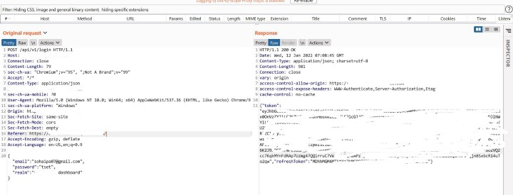

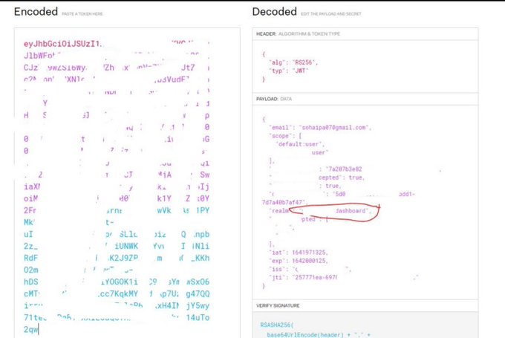

1
13
40



Information Warfare Center

@cyberintel

·
Apr 4, 2022
Roxy File Manager 1.4.5 PHP File Upload Restriction Bypass https://packetstormsecurity.com/files/166585 #exploit
1
1



we45

@we45

·
Jul 12, 2022
Have you come across file upload #vulnerabilities? Learn what common attack vectors can be used to exploit improper file upload functionality and bypass common defense mechanisms. https://we45.com/post/how-to-exploit-file-upload-vulnerabilities-and-how-to-fix-them… #appsec #devsecops



we45.com
How to Exploit File Upload Vulnerabilities (and How to Fix Them!) | we45 Blogs
File upload vulnerabilities arise when a server allows users to upload files without validating their names, size, types, content etc. In this article, we will learn common attack vectors that can be...



Sploitus

@sploitus_com

·
May 18, 2021
Subrion CMS 4.2.1 - File Upload Bypass to RCE (Authenticated) https://sploitus.com/exploit?id=EDB-ID:49876… #Exploit #Sploitus



@Chahali

·
Feb 21
Upload_Bypass_Carnage - File Upload Restrictions Bypass, By Using Different Bug Bounty Techniques! https://bit.ly/3YTMXma #TLS

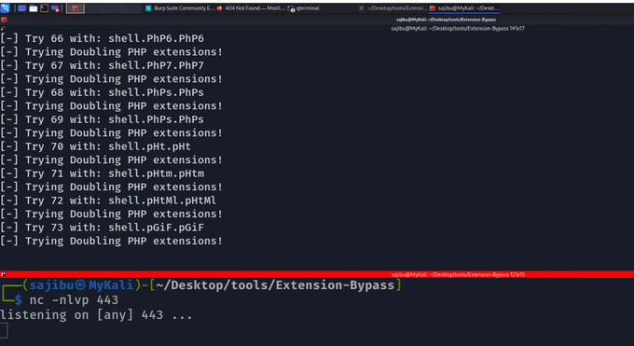

3

536

Md Ismail Šojal

@0x0SojalSec

·
Nov 7, 2022
WAF Bypass During Exploitation Of File upload Fire /?file=shell.php <-- Blocked /?file=shell.php.jpg <-- Blocked /?file=shell.php5 <-- Blocked /?file===shell.php <-- Bypassed 200 OK #infosecurity #bugbountytips #security #waf #bypass
6
78
319



H4x0r.DZ

@h4x0r_dz

·
Oct 19, 2022
My new writeup: 23000$ for Authentication Bypass & File Upload & Arbitrary File Overwrite

medium.com
23000$ for Authentication Bypass & File Upload & Arbitrary File Overwrite
How I found Authentication Bypass >> File upload vulnerability >> Arbitrary File Overwrite and how I managed I found the path of the file…

98
495
1,813

Md Ismail Šojal

@0x0SojalSec

·
Nov 24, 2022
Bypass File Upload Filtering : In image : exiftool -Comment='<?php echo "<pre>"; system($_GET['cmd']); ?>' shell.jpg mv shell.jpg shell.php.jpg #bugbountytip #infosec #cybersecuritytips
3
106
296

Md Ismail Šojal

@0x0SojalSec

·
Mar 11
File upload WAF bypass : by
@0xJin
/?file=shell.php <-- Blocked /?file===shell.php <-- Bypassed #infosec #bugbounty #bugbountytips
8
96
344

26.8K



Farhan

@FaniMalikHack

·
Aug 18, 2021
File Upload Bypass

we45

@we45

·
Jul 12, 2022
Have you come across file upload #vulnerabilities? Learn what common attack vectors can be used to exploit improper file upload functionality and bypass common defense mechanisms. https://we45.com/post/how-to-exploit-file-upload-vulnerabilities-and-how-to-fix-them… #appsec #devsecops

we45.com
How to Exploit File Upload Vulnerabilities (and How to Fix Them!) | we45 Blogs
File upload vulnerabilities arise when a server allows users to upload files without validating their names, size, types, content etc. In this article, we will learn common attack vectors that can be...

3
8



Sagar Sajeev

@Sagar__Sajeev

·
Aug 13, 2022
Do checkout my new writeup on a File Upload Bypass leading to RCE. https://sagarsajeev.medium.com/file-upload-bypass-to-rce-76991b47ad8f… #bugbounty #cybersecurity #bugbountytips #vulnerabilities #redteam #infosec

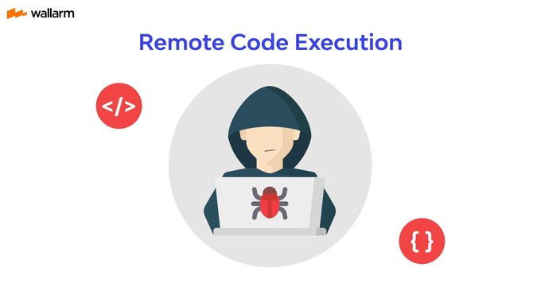

sagarsajeev.medium.com
File Upload Bypass to RCE == $$$$
Multiple ways to Bypass a File upload feature and chain it to an RCE.

2
12



Party Hack!

@Party_Hack

·
Feb 18
Upload_Bypass_Carnage - File Upload Restrictions Bypass, By Using Different Bug Bounty Techniques! http://dlvr.it/SjcYLJ

3

664



iSecurity

@iSecurity

·
Aug 12, 2022
File Upload Bypass to RCE == $$$$ http://dlvr.it/SWVlq3 #cybersecurity #vulnerability #hacking

sagarsajeev.medium.com
File Upload Bypass to RCE == $$$$
Multiple ways to Bypass a File upload feature and chain it to an RCE.

1



Towards Data Science

@TDataScience

·
Jul 27, 2020
How to Spit a Pickled Model File to Bypass Upload Limits on PythonAnywhere by Jacob Tadesse
窗体顶端

窗体底端

Top

Latest

People

Media

Lists

See new posts

Search timeline



Begin n Bounty

@beginnbounty

·
Mar 24
The Hidden Dangers of File Uploads: Some Bypass Techniques: Thread : File upload vulnerabilities arise when a web server allows users to upload files to its file-system without sufficiently validating things like their name, type, contents, or size.



1
39
117

10.8K



Het Mehta

@hetmehtaa

·
Oct 22, 2022
23000$ for Authentication Bypass & File Upload & Arbitrary File Overwrite
@h4x0r_dz
#infosec #bugbounty #thesecureedge

medium.com
23000$ for Authentication Bypass & File Upload & Arbitrary File Overwrite
How I found Authentication Bypass >> File upload vulnerability >> Arbitrary File Overwrite and how I managed I found the path of the file…

17
51



Wolfgang Sesin

@WolfgangSesin

·
May 17, 2021
New post from http://sesin.at ([webapps] Subrion CMS 4.2.1 - File Upload Bypass to RCE (Authenticated)) has been published on https://sesin.at/2021/05/17/webapps-subrion-cms-4-2-1-file-upload-bypass-to-rce-authenticated/…

